**BDD Testing Overview for Team Scrumdiddlyumptious Sprint #3**

# Overview

Cucumber and Selenium were used to automate BDD tests. 3 more BDD scenario tests were created during this sprint to validate the three stories completed in this sprint.

1. Select school
2. Search class list by course number
3. Search class list by title

# Feature Files

## BDD Feature File #3 (searchBox)

3 scenarios are in the seachBox feature file

1. Search class list by title
2. Search class list by course number
3. Search class list by school (fulfills Select school requirement)

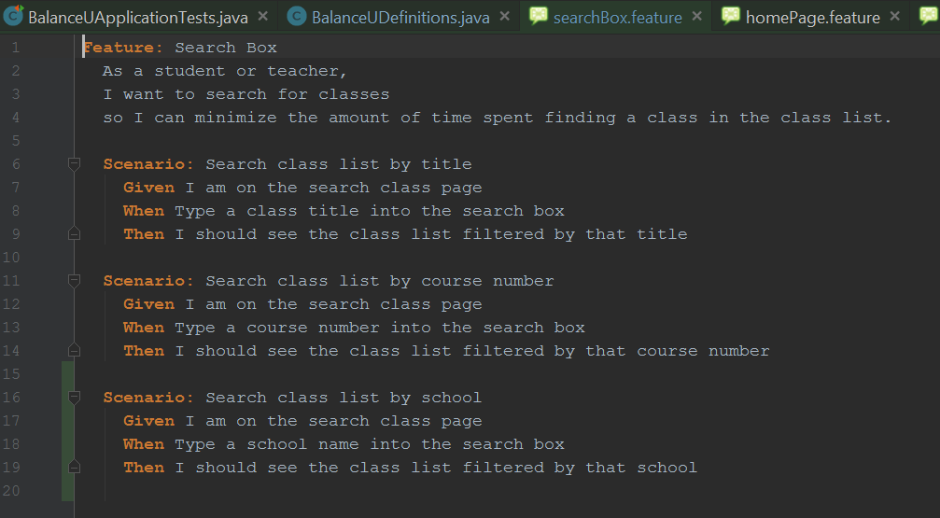

Step Definition for “Search class list by title”

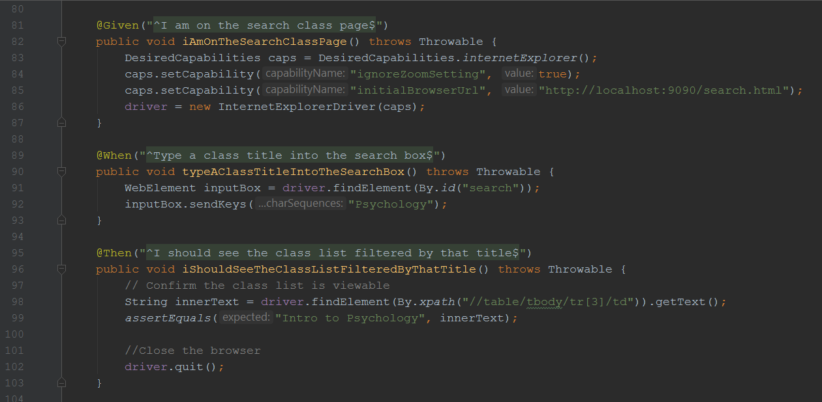

Step Definition for “Search class list by course number”

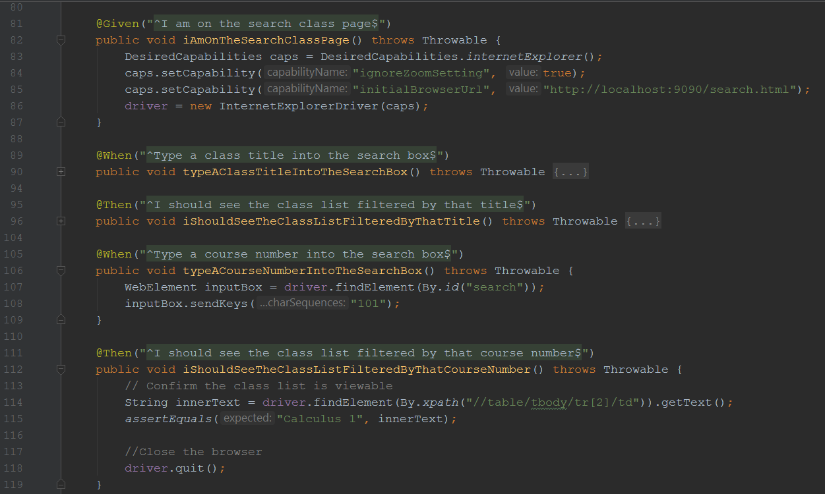

Step Definition for “Search class list by school”

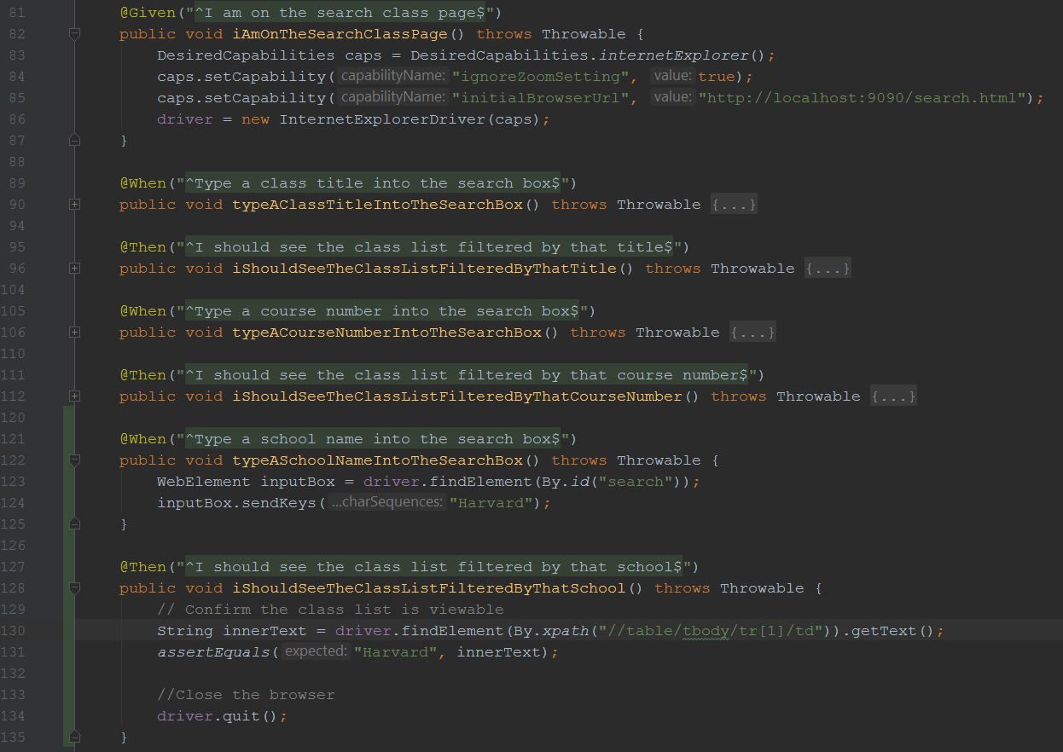

# BDD Test Run Results

All BDD tests ran using Cucumber and Selenium and passed.

